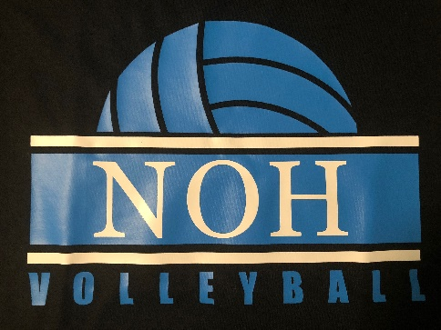
Order Form
Black White Gray
T-Shirts $10.00 Small:_______ Small:_______ Small:_______
Medium:_______ Medium:_______ Medium:_______
Large_______ Large_______ Large_______
X-Large:_______ X-Large:_______ X-Large:_______
Other:______ Other:______ Other:______

Hoodies $25.00 Small:_______ Small:_______ Small:_______
Medium:_______ Medium:_______ Medium:_______
Large_______ Large_______ Large_______
X-Large:_______ X-Large:_______ X-Large:_______
Other:______ Other:______ Other:______

Crewneck $20.00 Small:_______ Small:_______ Small:_______
Medium:_______ Medium:_______ Medium:_______
Large_______ Large_______ Large_______
X-Large:_______ X-Large:_______ X-Large:_______
Other:______ Other:______ Other:______

Name:__________________________ Total:___________________
Cash or checks payable to Ted Whitsel

